Merced College

PARAMEDIC ADVISORY COMMITTEE MEETING

Minutes

Friday February 25, 2022
12:00 p.m. – 1:30 p.m.
PSC-Public Safety Complex-1
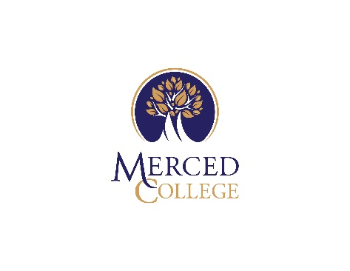

Facilitator: Chief Derek Parker and Professor Steven Melander
Note Taker: Maria Soto

Attendees: Dr. Valerie Albano; Carly Alley, Ashley Baxter, Mickey Brunelli, Kitty Cazares, Thomas England, Ross McKee, Dr.Tushar Patel, Scott Silveira, Libby Soria, Tim Williams, Casey Wilson, and Kristi Wolf.

- Welcome
Chief Derek Parker welcomed everyone. Introductions were made by all attendees.
- Packets were issued with the following:
  - Agenda
  - Sample Course(s) Schedule

- Program Overview (First Cohort – Fall 2022/Spring 2023/Summer 2023
  - Program was initially initiated by Professor Bryan Donnelly back in 2013. In which he put a lot of work and research into getting the courses approved thru Curriculum. Currently Melander and Chief Parker are in the process of finalizing it to be approved as an AS degree program and also a certificate.
  - The director(s) will consist of both Professor Steven Melander and Chief Derek Parker just for the 1st semester then after it will be overseen by only Melander; both are experienced Paramedics and have worked together in the past.
  - Start date is August 15, 2022.
  - Deadline to the Chancellors office for approval is at the end of March, 2022.
  - First Cohort will have a cap of 30 students.

  - Semester courses will be taught are follows:
    - EMER-10 & 11 Fall 2022
    - EMER-20 & 21 Spring 2023
    - EMER-30 & 31 Summer 2023
      - Consist of the following:
        - EMER-10 Paramedic 1 Units 12.5 Lecture 12.25hrs/Lab.75hrs
        - EMER-11 Paramedic 1 Lab Units 1.5
Lab 4.5hrs
        - EMER-20 Advanced Paramedic Units 11.5
Lecture 11.5
        - EMER-21 Advanced Paramedic Lab Units 1.5
Lab 4.5
        - EMER-30 Paramedic-Acute Clinical lab Units 3
Lab 9hrs
        - EMER-31 Paramedic Field Experience Units 9
Lab 27hrs
  - Program will be taught as a Hybrid.
    - Synchronous; break out groups
      - Beneficial to students; can work on their own time.
      - Students will be monitored at all times.
    - A-Synchronous
      - Assigned time.
      - Accounting of hours a student is logged in to online learning management system.
- Students will be required to be on site at least 1 day per week for supervised testing and clinical skills laboratory.
- Clinical and Field Experience courses will be offered as an ISA.
  - An agreement between Merced College and provider agency (Merced FD).
  - Merced College Allied Health programs will add an addendum to add the Paramedic program to existing contracts as well as securing new clinical contracts with surrounding ambulance providers. Several are in progress.
  - An example was provided as to how Sacramento State Paramedic program has had a great success rate at 90% pass rate with National Registry testing; see attachment.
  - Passing will be based on the National Registry.
  - Advanced Certificate level.
  - Degree program (AS.)
  - Will consists of 39 units towards a 2yr degree and Course Completion Certificate.

- Program Staff Introductions
  - Medical Director – Dr. Patel
  - Area Dean – Dr. Albano
  - Program Director(s) – Derek Parker & Steven Melander
  - Clinical Coordinator – Mickey Brunelli
  - Public Safety Coordinator – Maria Soto
  - Principal Instructor(s) – Steven Melander, Ashley Baxter
  - Adjunct Instructors – local, experienced Paramedics & RNs

- Paramedic Program Approval Process
  - CoAEMSP Submission/Accreditation/CAAHEP Experience
    - Initiated the process.
    - Will provide regular updates.
  - MCEMSA Letter of Authorization
    - Melander is currently working on it.
  - Curriculum Committee
  - Chancellor’s Office
  - ACCJC
    - Requires many levels of approvals

- Advisory Committee Representation
  - Program Director(s)
  - Medical Director
  - Faculty Member(s)
  - Physician(s)
  - Public Member(s) at Large
  - Merced County EMS Agency
  - Merced County FD Provider
  - Merced County Ground Ambulance Provider
  - Merced County Air Ambulance Provider
  - Merced County Paramedic Base Hospital
  - Merced College (non-public safety)
  - Graduate(s) (pending)
  - Student(s) (pending)

- Identify Committee Chair – action Item
  - Work with Program Director.
  - Will meet 1 Cohort annually.
  - Next meeting will be in June 2022.
  - A motion to have Scott Silveira as the Paramedic Committee Chair; moved by Merced County Supervisor Silveira. The motion carried with all in favor; motion passed.

- Community Needs, Program Support – action item
- Chief Parker and Steven Melander provided a summary description of the Paramedic shortage felt locally, throughout the state and nationally and the need for additional training sites to meet the current and forecasted need.
  - A motion to support a Paramedic training program at Merced College; moved by Merced County Supervisor Silveira. The motioned carried all in favor; motion passed.

- Paramedic Program Minimum Competencies (2023 standards) – action item
  - FISDAP will be used to track hours and skills competency tracking.
  - 2023 Competencies chart attached for specifics.
  - A motion to accept the minimum competencies as 2023 standards; moved by Merced County Supervisor Silveira. The motion carried with all in favor; motion passed.

- Textbooks – final list review and approval – action item
- A motion to approve the following textbooks (see list below); moved by Merced County Supervisor Silveira. The motioned carried with all in favor; motion passed.
- Includes a Navigation with premium materials.
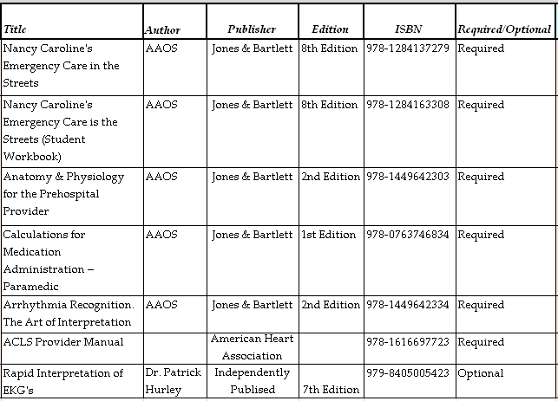

- Clinical Laboratory Layout – action item
  - Multiple sites
  - Set-up real life scenarios
    - ER settings
    - Ambulance settings
    - Living area; view behind the glass
    - Prepare a patient for transport
- A motion to accept the Scenario based learning to achieve the outcomes; moved by Merced County Supervisor Silveira. Motion carried with all in favor; motion passed.

- Ongoing Meeting Schedule
  - Next meeting June 15, 2022 at noon till 1pm in PSC-1; lunch provided

- Other
  - Merced County Supervisor Silveira stated that there is a shortage in the community and what is the incentive to have students stay here once they are done.
    - Internships offered locally
    - Present success stories
    - Keynote speakers (local providers)
  - Chief Parker discussed National Registry skills and written testing procedures and an authorized testing site.
  - Desire to have Merced College approved as a National Registry skills testing site and a Pearson VUE authorized testing center for the written component as well as other certifying examinations such as NCLEX.

- Adjournment at 1:35p.m.

Respectfully, Maria Soto, Area Administrative Coordinator

